**Squash**

Striking and Hitting

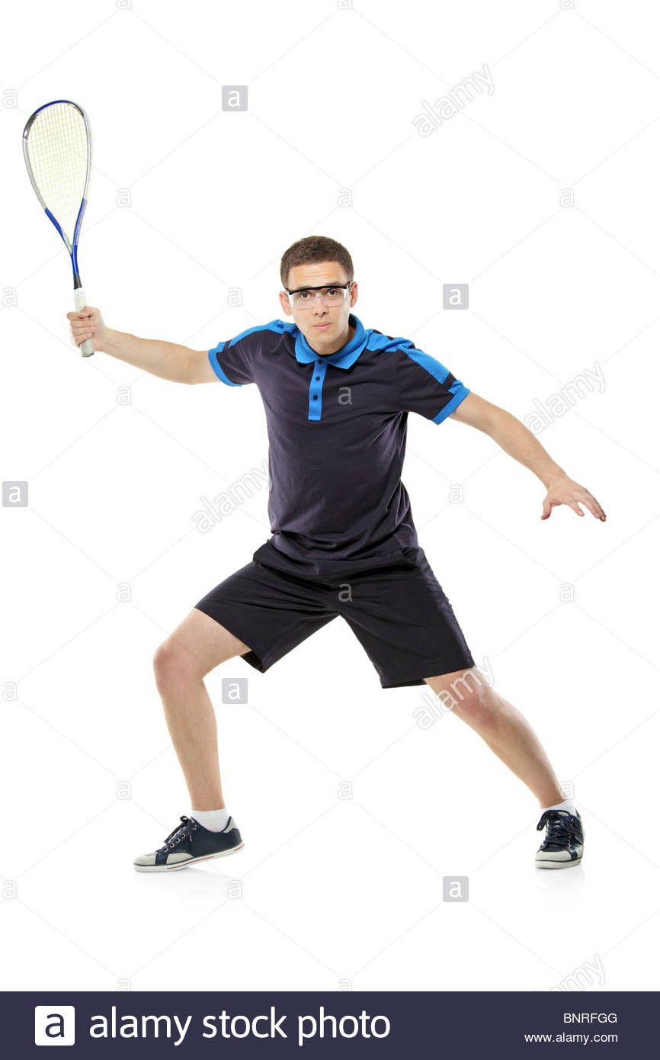

* Hand eye coordination
* Movement
* Spatial awareness
* Focus
* Racket skills

Core skills

Performance