Replication

**HRF**

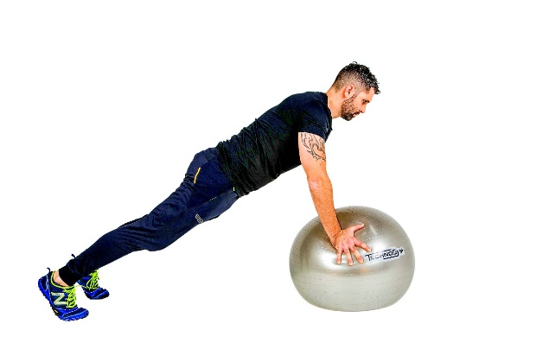

* Circuit training and Metafit Interval Fartlek – Bones + Muscles

* Circuit training and Metafit Interval Fartlek – Bones + Muscles
* Components of Fitness – cardiovascular endurance
* Muscular endurance
* Flexibility
* Body Composition
* Pulse Taken
* Recording results
* Technique
* Effort / Enthusiasm
* Level of fitness (recovery)

Cross country   
(time will be the   
assessment indicator)

Performance at   
max

Testing performance

Core skills

* Components of Fitness – cardiovascular endurance
* Muscular endurance
* Flexibility
* Body Composition
* Pulse Taken
* Recording results
* Technique
* Effort / Enthusiasm
* Level of fitness (recovery time)