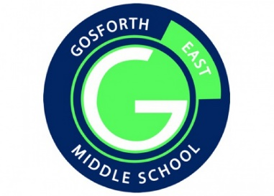
Gosforth East Middle School
OPAL play newsletter
September 2024

Thank you!
Firstly, we would like to thank all the families who have donated materials, toys and play equipment so far! It is greatly appreciated and helps us to improve the play opportunities on offer at GEMS for all students.
This month students have been busy in lots of areas of play. Football, running on the Telly Tubby hills, chatting with friends and scooting have all been popular.
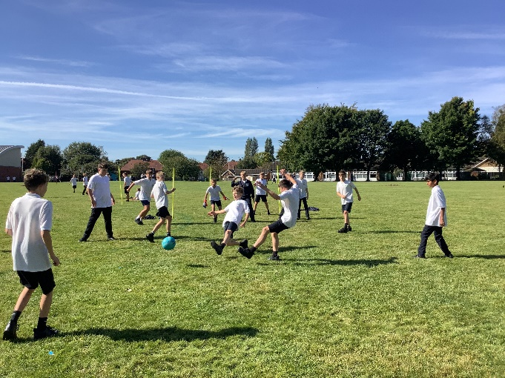 | 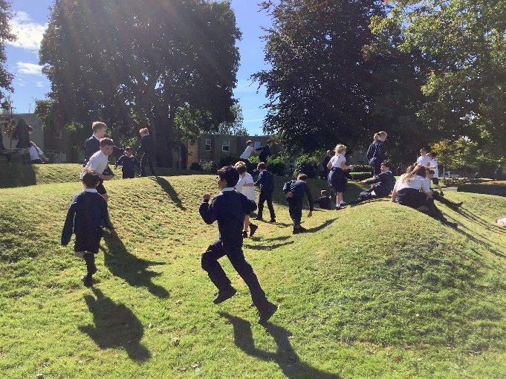
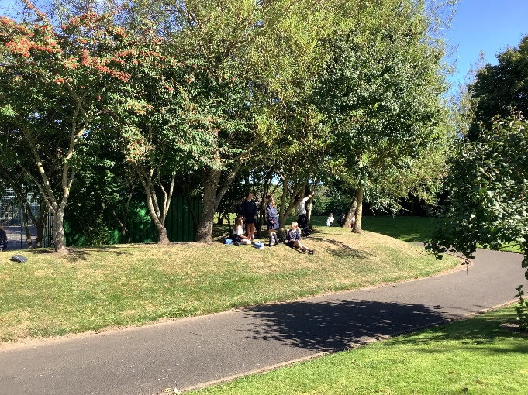 | 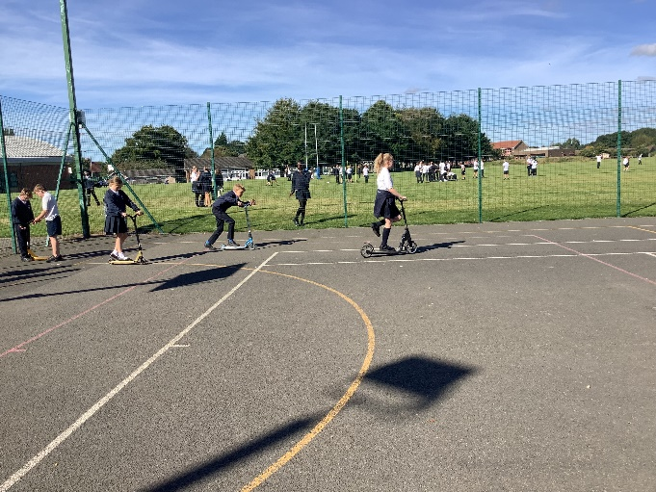

We would also like to introduce OPAL class bingo. Each class is aiming to bring in all the things on their list. The first class to get everything will get an extra breaktime and 50 house points. Every class that brings everything can get 50 house points as well. Thank you in advance for all your contributions and continued support to our school with OPAL play.



