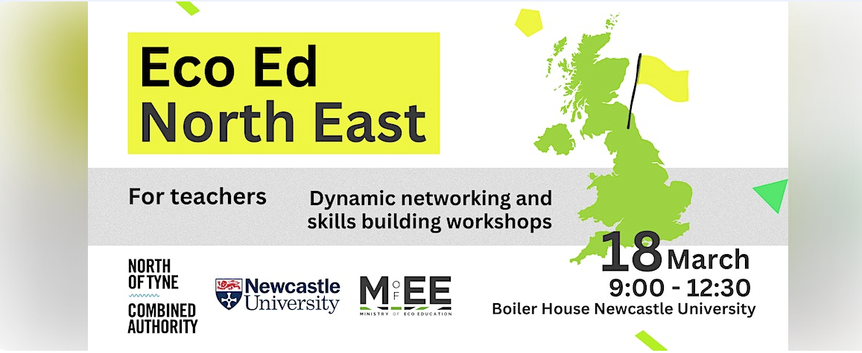

Book your free tickets now!

Eco Ed North East is your opportunity to meet representatives from organisations supporting schools in our region to embed climate and sustainability education throughout the curriculum.

By 2025, The Department of Education suggests that all schools will require a sustainability lead and a climate action plan. This gathering includes presentations and workshops to allow teachers to confidently and inspirationally engage with this process.

Join us and follow the link for further information and to book your tickets.

Eco Ed North East Tickets, Mon, Mar 18, 2024 at 9:00 AM | Eventbrite

