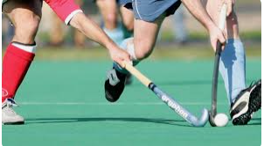

Hockey

- Push passing
- Receiving of push pass
- Body position
- Ball control
- Shooting
Striking and hitting
Passing and receiving

Core skills
Performance
Attacking /Defending

- Push passing
- Receiving of push pass
- Block tackling
- Match performance
- Ball control
- Shooting

- Push passing
- Receiving of push pass
- Block tackling
- Body position
- Ball control
- Shooting
- Match performance

- Push passing
- Receiving of push pass
- Block tackling
- Body position
- Ball control
- Shooting

