Volleyball

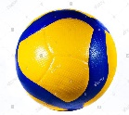
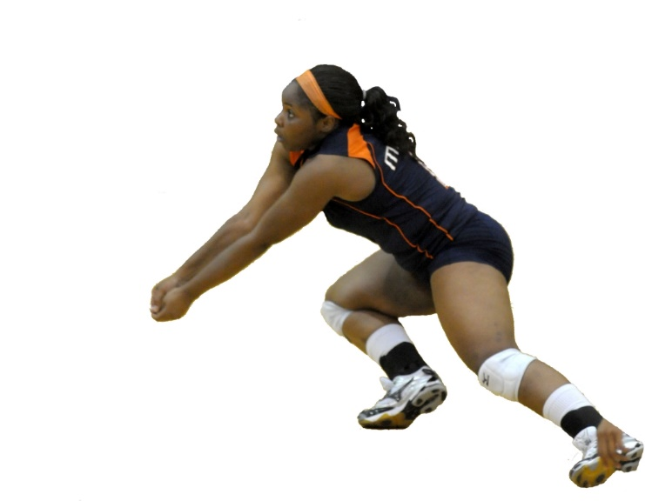
Attacking
Defending
- Serving
- Volley and dig shots
- Body positions
- movement
- Hand position rules
- Awareness of self

- Serving
- Volley and dig shots
- Body positions
- movement
- Hand position rules
- Awareness of self

Core skills
Performance

