Rugby

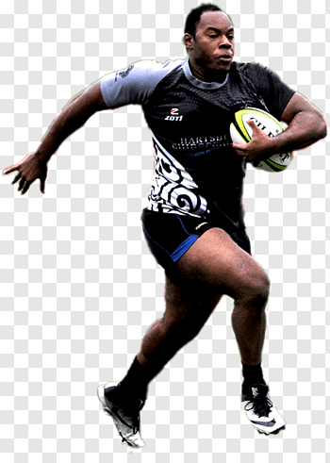
- Ability to tackle well front and side whilst being safe
- Uses side stepping
- Attacks well supports play
- Scrum Line out
- Kicking grubber bomb place punt.

- Able to tackle safely and be tackled safely
- Passes from both side with degree of success
- Passing at speed and receives well
- Side stepping and feints dummy to opponents
- Performance in Games.

- Demonstrates basic defending (e.g. Line) supports runner with the ball
- Runs to space with the ball, begins to close
- Defend space.
- Tackles well, receives ball when on the move.
- Swerves
- Runs at angles to avoid tackles.

Passing and receiving
Performance

Defending
Moving with the ball
Attacking
- Passing well off stronger side
- catching receiving the ball runs well with ball in two hands
- Tag tackles and understands the procedure.
- How to score + ball passed back basic principle.

