- Observes and copies basic travel skills
- Knows the three elements of a sequence
- Preparation of and performance of sequence
- Rolls/Jumps/balances.
- Co-ordinate body to perform balances
- Jumps control to shape in flight.
- Understand the importance of body tension
- Warm ups.
- Movements in relation to music
- Demo of repetition
- Simple changes of direction and speed
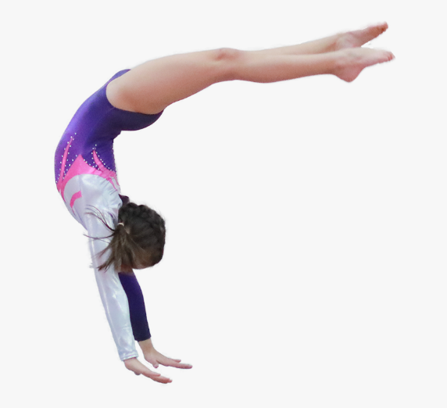
- Ability to do front / log / circle with added variation
- Understands difference with wheeling and rolling
- Take off flight and landing
- Preparation of sequence performing in pairs, showing direction, level speed
- Showing precision control and fluency

- Ability to do basic jumps.
- Moving into and out of jumps.
- Moving into and out of individual actions showing precision, control and fluency.
- Perform with a range of skills and movements clearly showing good body control and tension.
- Timing, working in unison and with awareness of the group.
- Able to identify improvements needed.

- Shows and knows the correct start and finish
- Fluency in rolls and in flights
- Prepares a sequences with unison match mirror cannon (partner work)
- Performs hand / head stands /backwards rolls / cartwheel
- Unison cannon shown within the dance performance
- Fluency, control and precision
- Posture and expressive actions

Gymnastics/Dance

Accurate replication
Exploring and
communication
Performance
Evaluation

