Cricket & Rounders

- Performs a batting stance
- Strikes a ball when batting
- Holds bat correctly
- underarm bowling rounders overarm cricket
- Catching cups hands watching ball
- Fielding behind the ball
- Throwing accurate short or long

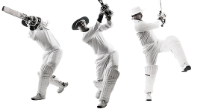

Performing
Striking and hitting
Bowling and receiving
Replication and core skills

- Accurate when bowling rounders and cricket stationary/static
- Accurate when batting
- Moves towards the ball when fielding
- How to improve all aspects
- Moves towards the ball when fielding
- How to improve all aspects
- Distance on throwing
- Demonstrate competently when fielding
- Good batting
- Bowling accurate pace and variety
- Good placement when batting
- Catching one handed
- Bowling actions/ Walking in on fielding back up
- Understand where batters are hitting shots and react to this
- Catching consistently more often than not
- Attacking and defensive shots
- Base work

