Badminton

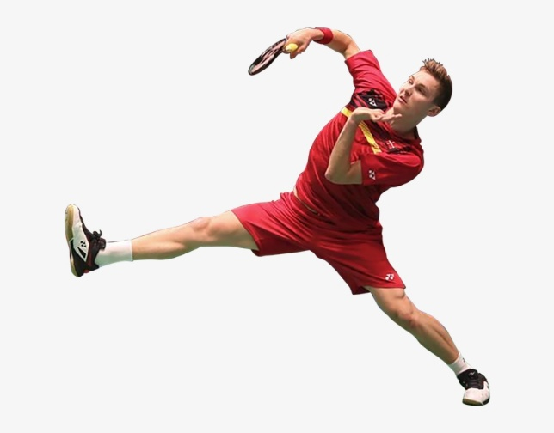
- Incorporates power and deception
- Disguises shot and the above years

- Overhead shots focus clear drop and smash
- Movement
- Footwork
- Tactical awareness plus above i.e. year 6 objectives
- Lessons

- Serving
- Rallying groundstrokes forehand and backhand shots
- Overhead shots length distance
- Rules
- Body position set up
- Hand eye co-ordination

Core skills
Attacking / Defending
Replication
Performance

