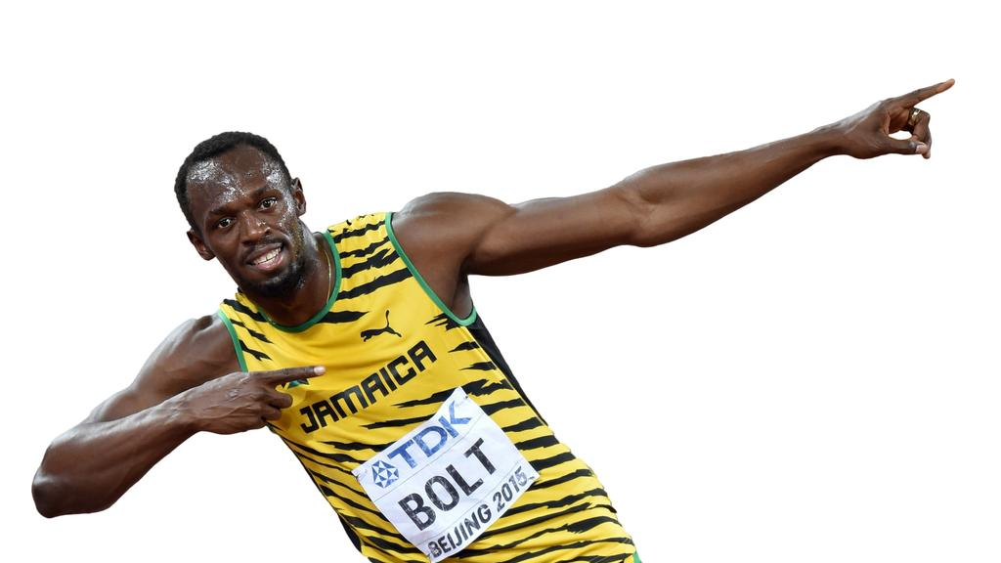
Athletics
- Time
- Distance
- Height (performance)
- Drives arms and legs when sprinting
- Good balance on throwing
- Recognises strengths and weaknesses in self and in others in all events

Exercising safely
Core skills
Testing performance
Replication
Performing at max
Problem solving
- Able to perform standing start
- Release at the correct height when throwing
- Release at the correct speed when throwing
- Release at the correct angle when throwing
- Drives arms on jumps
- Time/Distance/Height (performance)
- Time
- Distance
- Height (performance)
- Takes off with power and reaches forward
- Position in flight
- Speed on run

